Exercise No: 4

Date: 13-10-2020

Aim:

To write a Python program (function) to print a single string from two set of strings received from user and swap the first two characters of each string.

Program:

def swap(str):

new =""

for x in str:

new +=x

return new

a = input()

b = input()

str1 = a.strip()

str2 = b.strip()

if(len(str1)>=2 and len(str2)>=2):

t1 = list(str1)

t2 = list(str2)

c1 = t1[0]

c2 = t1[1]

t1[0] = t2[0]

t1[1] = t2[1]

t2[0] = c1

t2[1] = c2

str1=swap(t1)

str2=swap(t2)

print(str1,"",str2)

else:

print("Invalid")

Link:

[http://103.53.53.18/mod/vpl/forms/edit.php?id=234&userid=1706#](http://103.53.53.18/mod/vpl/forms/edit.php?id=234&userid=1706)

Output:

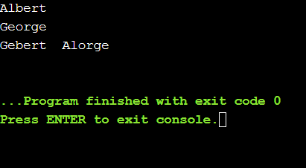

Result:

Thus the output for the Python program (function) to print a single string from two set of strings received from user and swap the first two characters of each string was verified.